TERRIA: More applications and even higher efficiency
Flexible TEGOSEM hopper and TRACTION CONTROL

Following the distribution system package featuring fertiliser boots, more equipment options are now available for all the models in the TERRIA range of Pöttinger, the trailed stubble cultivators with three or four rows. For even more applications and higher efficiency, the stubble cultivators are now available with the proven TEGOSEM flexible hopper for sowing seed and applying micro-granules. This makes it easy to combine tillage and drilling a cover crop, or applying fertiliser in a single pass. With the TRACTION CONTROL system, the weight of the stubble cultivator is shifted to the rear axle of the tractor. Less wheel slip is the result, allowing the tractor to deliver power to the ground more efficiently.

Good for the soil
Working efficiently is becoming increasingly important in the field to take full advantage of planting time frames in addition to meeting deadlines for sowing cover crops after harvest. The TERRIA with the flexible TEGOSEM hopper and a capacity of 500 litres makes this possible. By establishing ground cover rapidly and extensively, unproductive water evaporation is prevented. Likewise, excess nitrogen in the soil is absorbed by the plants and retained on site. Improving and stabilising the soil structure with organisms increases water infiltration while reducing the risk of erosion. By carrying out both tasks in a single pass, the flexible hopper saves time and costs. Reducing the number of passes conserves the soil and any harmful compaction is avoided.
Simple and precise
The flexible TEGOSEM hopper from Pöttinger is equipped with an adaptable metering shaft. This is electrically controlled depending on the driving speed, and it switches off automatically at the headland. Before starting work, the system is optimised by means of a calibration test. A hydraulic fan ensures reliable transport of the material to the distribution plates. To ensure a uniform spread of material close to the ground and to be able to vary the application point, the angle of the distribution plates can be adjusted by twisting the shaft. The aim is to deposit the seed material in front of the rear roller or at the rear roller for optimum germination conditions. A clear and intuitive control terminal is available for operating the flexible TEGOSEM hopper. This is used to optimise the settings according to the operating conditions. For increased convenience, the flexible TEGOSEM hopper is equipped with additional features, including a level sensor.

Delivering full pulling power
Increased wheel slip not only damages the structure of the soil, it also reduces cost effectiveness by increasing fuel consumption. In order to use the power of the tractor as efficiently as possible, the drawbar can be equipped with the TRACTION CONTROL hydraulic pulling power booster. This system transfers weight from the stubble cultivator to the rear axle of the tractor. The pressure in the drawbar cylinder can be adapted for different working depths. A weight of up to 1,400 kg can be transferred this way. Ultimately, the system reduces operating costs and increases the efficiency of the machine.

High yield levelling
Producing a level working pattern is essential for the follow-up tasks and uniform seed emergence. To further improve levelling in locations with light soil types, TERRIA models with tandem rear rollers can now be equipped with an optional levelling board instead of the concave discs. This creates even and uniform working results and positively influences the tilth.

Moves more
TERRIA trailed stubble cultivators with 3 or 4 rows and a working width of four to six metres (TERRIA 4030, 5030, 6030, 4040, 5040, 6040) can handle a wide range of tillage applications. Especially the option of the flexible TEGOSEM hopper increases versatility even further and enables tasks to be combined into a single pass. In addition, the TRACTION CONTROL system uses the weight of the stubble cultivator to optimise the tractor's power to the ground and helps to increase efficiency.

Photo preview:
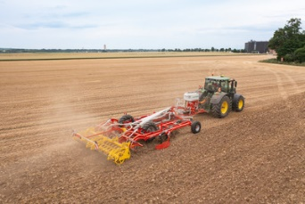 | 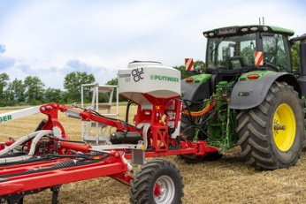
The TERRIA 4040 offers even more applications | Efficient work with TERRIA 4040 and TEGOSEM 500. TRACTION CONTROL to optimise the tractor’s power
https://www.poettinger.at/de_at/newsroom/pressebild/102085 | https://www.poettinger.at/de_at/newsroom/pressebild/102086

More printer-optimised photos: http://www.poettinger.at/presse

